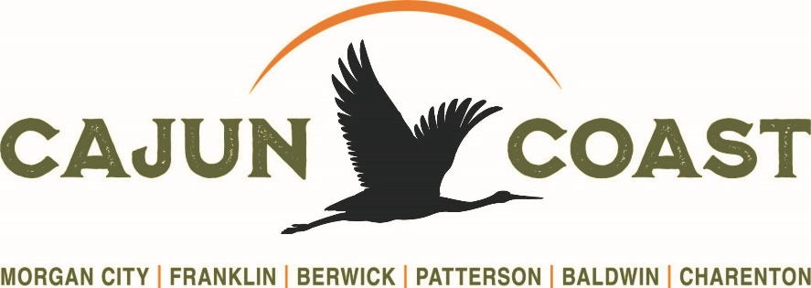

2026 Festivals and Special Events Reimbursement
Grant/Sponsorship Program
$1000.00 to $5000.00

Overview:
St. Mary Parish Tourist Commission dba Cajun Coast Tourism’s mission is to promote and establish St. Mary Parish as a premier leisure and sports destination engaging in programs that generate overnight stays, thereby enhancing and developing the economic fabric of the community.

The purpose of the Festivals and Special Events Reimbursement Program is to enhance a festival or event that has the potential to promote economic development through tourism, increase hotel/motel occupancy and create net economic impact by increasing sales to attractions, restaurants, retail outlets, etc. The sponsorship/grant program is on a case-by-case.
The SMPTC dba Cajun Coast Tourism is funded via a hotel/motel tax. Hotel rooms booked is one metric that will utilized in the evaluation of the awarding said grant/sponsorship.

Application Requirements:
▪ Funds requested are to be used for advertising in the form of print, digital, tv or radio, marketing materials such as brochures, rack cards, special promotional items, website, speaker, celebrity or musician fees. Brochures, rack cards or flyers for fund-raising are not acceptable.
▪ Application must describe specific details of the advertising/marketing plan.
▪ Funds shall not exceed $5000.00 per application. Applications may not be fully funded, if at all. It is important to consider additional sources of funding. As a reminder, all funding for the grants listed above are driven by hotel/motel tax collections.
▪ Applicants may submit only one request annually. Entities that host more than one event may be considered on a case-by-case basis.
▪ Applications must be received no later than three months prior to the date of the event to be considered.
▪ The Festival-Special Event Reimbursement Grant Program will be subject to availability of funds of the St. Mary Parish Tourist Commission dba Cajun Coast Tourism.
▪ Applicants cannot transfer funds from one event to another event
▪ Additional documentation may be requested
▪ Applicant must provide follow-up form after event/festival to SMPTC dba Cajun Coast Tourism (including # attendance, # tickets sold, cities and/or states attendees came from and # hotel rooms used during the event/festival) no less than 90 days after the event.

Application Review Process:
▪ Once the completed documentation has been received by SMPTC dba Cajun Coast Tourism, it will be reviewed by the SMPTC dba Cajun Coast Tourism team and Executive Committee and voted by the Board.
▪ Applications will be evaluated based on the following criteria:
•the merit/quality of the event/festival
•the potential of the event to bring tourists to the parish
▪ Once an application is approved by the St. Mary Parish Tourist Commission dba Cajun Coast Tourism, a Cooperative Endeavor Agreement (CEA) will be executed for
both parties to sign.
▪ The CEA will outline the amount of the Festival and Special Event Reimbursement Grant awarded and the services to be rendered in exchange for the Festival and Special Event Reimbursement Grant.
▪ SMPTC dba Cajun Coast Tourism will REIMBURSE the applicant for the approved amount once SMPTC dba Cajun Coast Tourism receives proof of payment of invoices including copies of the check(s) showing payment(s), proof of performance (affidavits for radio) including ads with Cajun Coast Tourism logo or name, photos of the band, speaker, screen shots of digital media, screen shot of website, etc. and the follow-up form
▪ All required documents must be submitted to SMPTC dba Cajun Coast Tourism no later than ninety (90) days after the event date in order to receive reimbursement.

Guidelines for Eligibility:
▪ Events/Festivals/major sporting events that will increase visitation and overnight stays in the parish
▪ Events/Festivals must be a recognizable organization and must aim at increasing visitor traffic and promoting tourism to the parish
▪ Events/Festivals must be held in St. Mary Parish
▪ Events/Festivals must be open to the public
▪ Events/Festivals must take place during the budget year for which it is funded
▪ Projects must be tourism related

Non-Eligible Events:
▪ Family reunions and bazaars
▪ Fund raisers for individuals, groups, schools, or churches
▪ SMPTC dba Cajun Coast Tourism reserves the right to accept or deny all applications without cause.
▪ It is the responsibility of the applicant to supply all requested information at the time of submission.
▪ Incomplete forms may be discarded without notice to applicant.
▪ SMPTC dba Cajun Coast Tourism is not responsible for late applications.

Recognition:
▪ The official SMPTC – Cajun Coast Tourism logo and website www.cajuncoast.com or name must be included in and on all advertising.
▪ SMPTC dba Cajun Coast Tourism will provide a list of accommodations and tourist information to the applicant. A list of St. Mary Parish accommodations must be included in all information packets being sent to participating vendors/teams for all level requests.

Payment:
▪ All required documents must be received within the time allotment as stated above in the Application Review Process
▪ Proof of payments should be for advertising/marketing only unless otherwise specified in the CEA
▪ Payment(s) will be made directly to the organization requesting the funds as a reimbursement only
▪SMPTC dba Cajun Coast will cut no more than two checks per application.

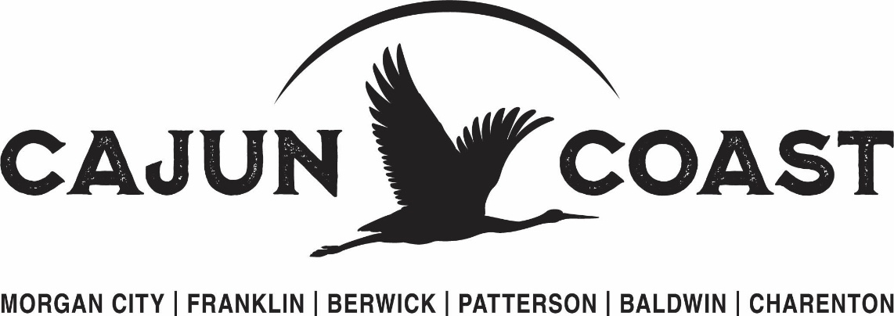

2026 Festival and Special Events Reimbursement Grant Application
Application MUST BE COMPLETE to be considered.

Sponsorship Information:
- Amount Requested:
- Name of Event/Project:
- Event Date(s):
- Times of the Events:
- Location of Event:
- Is this a new event? Yes No If no, how long has this event/festival been in existence?
- Organization/Company hosting event:
- Business Name for Agreement:
- Is the organization a Non-Profit? Yes No (Please submit Secretary of State registration of good standing with application.) Tax ID
- Primary Contact:
- Billing Person Contact:
- Address:
- Phone:
- Email address:
- Total Budget for Event:
- Approximate number of hotel rooms

Describe the Event: Click or tap here to enter text.
- Total anticipated attendance:

- How are attendance figures gathered?

- Admission ticket prices: Adult: Child: Age: Vip:

- If free event, what is average cost for Food? Beverages?

- If free event, Number of Vendors? Average cost range of products?

- Host Hotel:

- If recurring event, number of hotel rooms from previous events:

- Anticipated Economic Impact:(SMPTC dba CCT has a formula that will be implemented to determine Economic Impact with your figures.)

Provide information on the organization requesting funds: Click or tap here to enter text.

Goals and Objectives: (Objectives must be quantifiable. For example: Increase attendance from 500 to 1000.)Click or tap here to enter text.

Event Budget: (Please complete budget form.)
How will funds by used: Please check:
Newspaper Social Media Radio Television
Billboards Website Brochures/rack cards
Posters/flyers Press releases/article Pod casts
Digital Musicians/Speaker/Band Stage/Other:

Media/Marketing Plan: (Please attach to the application.)

Anticipated Income or Revenue
Please include anticipated funding including cash, fees, and all sponsorships, grants, and funding support including the SMPTC dba Cajun Coast grant request. Add and remove line items as needed.

Sources of Revenue | Amounts
Cash on Hand | $
Admission/Ticket Sales | $
Participant and Entry Fees | $
Vendors | $
Other earned income (itemized) | $
Itemized income | $
Federal Grants | $
Listed source | $
State Grants | $
Listed source | $
Community/Foundation Grants | $
Listed source | $
Corporate Support | $
Fundraising | $
SMPTC – Cajun Coast Grant | $
In-kind Donations | $
Total Expected Revenue | $

Anticipated Expenses
Please provide a comprehensive Tourism Event Budget for the entire project. Add and remove line items as needed.
Expense Categories | Total Amount
Professional & Contract services | $
Logistics Expense – Shipping, Transportation, etc. | $
Insurance | $
Facility Rental | $
Security Services | $
Marketing and Advertising | $
Promotional Items | $
Office Supplies | $
Hospitality and Culinary Services (Staff) | $
Food and Beverage | $
Total Expenses | $

(Tourism Event Budget categories listed above reflect a typical budget and may be adjusted.)

