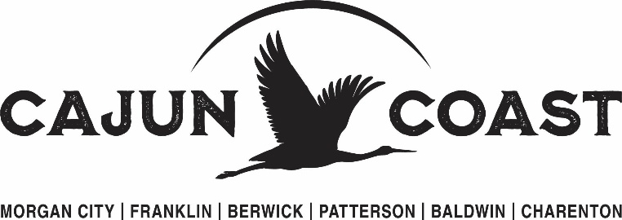

October 1, 2025

To Whom it May Concern,
The St. Mary Parish Tourist Commission dba Cajun Coast Tourism is now accepting applications for sponsorships.
There are two applications – one for grants/sponsorships $500.00 or less and one for grants/sponsorships for $1000.00 to $5000.00.
The application for $500.00 or less is simple and requires minimal deliverables. Applications for $1000.00 to $5000.00 are more comprehensive and require more deliverables.
This is a new process – so there may be flexibility on the timeline.
Applications will be on a case-by-case basis and based on funds available and potential impact to St. Mary Parish.
If you have questions, please contact Carrie Stansbury, 985-380-8224 or email, cstansbury@cajuncoast.com.
With kindest regards,
Carrie Stansbury
Executive Director

